
TASK 7 REPORT
Final Project Presentation: Mobile App for Collection of User Experience Data
CEF440: PROGRAMMING AND MOBILE PROGRAMMING

REPUBLIC OF CAMEROON

PEACE-WORK-FATHERLAND
BUEA, SOUTH WEST REGION
UNIVERSITY OF BUEA

FACULTY OF ENGINEERING AND TECHNOLOGY
(FET)

By:
GROUP 4 MEMBERS

COURSE INSTRUCTOR:

Dr. Engr. NKEMENI VALERY

Name | Matricule
AKO JUNIOR NGOH | FE23A008
ETUMA ELKINGS BOSANGO | FE23A053
MOUKAM HAKO BELLAMY STEVE | FE23A096
NJIKANG BRIGHT NDODE NGONE | FE23A115
RINGNYU MBUNWE GIYOH LEMUEL | FE23A136

Table of Contents
ABSTRACT 4
List of Figures 5
List of Tables 6
LIST OF ABBREVIATIONS 7
CHAPTER ONE: INTRODUCTION 9
1.1 Background of the Study 9
1.2 Problem Statement 9
1.3 Objectives of the Project 10
1.3.1 General Objective 10
1.3.2 Specific Objectives 10
1.4 Proposed Methodology 10
1.5 Significance of the Study 11
1.6 Scope of the Study 12
1.7 Delimitation of the Study 12
1.8 Organization of the Report 12
CHAPTER TWO: LITERATURE REVIEW 14
2.1 Introduction 14
2.2 Quality of Experience difference with Quality of Service 14
2.3 Existing Mobile Network Measurement Applications 14
2.3.1 OpenSignal 14
2.3.2 Network Cell Info Lite 15
2.3.3 TEMS Investigation and NEMO Handy 15
2.3.4 Speedtest by Ookla 15
2.3.5 Gap Summary 15
2.4 Crowdsensing as a Data Collection Paradigm 15
2.5 Mobile Background Services 16
2.6 Privacy Frameworks for Mobile Data Collection 16
2.7 Mobile Networks in Cameroon: Context 17
2.8 Partial Conclusion 17
CHAPTER THREE: ANALYSIS AND DESIGN 19
3.1 Introduction 19
3.2 Requirement Gathering Methodology 19
3.3 Functional Requirements 20
3.4 Non-Functional Requirements 21
3.5 System Architecture 22
3.6 UML and DFD Models 22
3.6.1 Context Data Flow Diagram (Level 0) 22
3.6.2 Level 1 Data Flow Diagram 23
3.6.3 Use Case Diagram 24
3.6.4 Class Diagram 25
3.6.5 Sequence Diagram Active Speed Test Flow 26
3.6.6 Deployment Diagram 26
3.7 Backend REST API Design 27
3.8 Database Design 28
3.8.1 subscriber_device 28
3.8.2 network_metric 29
3.8.3 location 29
3.8.4 Feedback 29
3.9 Key Design Decisions 30
3.10 Partial Conclusion 30
CHAPTER FOUR: IMPLEMENTATION AND RESULTS 32
4.1 Introduction 32
4.2 Tools and Technologies Used 32
4.3 Backend Implementation 33
4.3.1 Project Structure 33
4.3.2 Key Backend Features 34
4.4 Frontend Implementation 34
4.4.1 Project Structure 34
4.4.2 lib/ Module Architecture 35
4.4.3 Real Speed Test Implementation 36
4.4.4 Offline-First Architecture 37
4.5 Functional Gap Resolution 37
4.6 Screen-by-Screen Results 39
4.6.1 Onboarding Screen 39
4.6.2 Consent Screen 39
4.6.3 Home Screen (Real-Time Dashboard) 40
4.6.4 Test Screen (Active Speed Test) 41
4.6.5 Feedback Modal 43
4.6.6 History Screen 44
4.6.7 Settings Screen 45
4.7 Limitations and Challenges 46
4.7.1 iOS Background Execution 46
4.7.2 Signal Strength in dBm 46
4.7.3 Speed Test Accuracy 47
4.7.4 SQLite Encryption at Rest 47
4.8 Running and Deployment Procedure 47
4.9 Results and Evaluation 47
4.10 Partial Conclusion 48
CHAPTER FIVE: CONCLUSION AND FURTHER WORKS 50
5.1 Summary of Findings 50
5.2 Contribution to Engineering and Technology 50
5.3 FR/NFR Coverage Summary 51
5.4 Difficulties Encountered 52
5.5 Recommendations for Future Development 52
5.6 Project Conclusion Summary 53
REFERENCES 54
APPENDICES 55
Appendix A Survey Instrument (Mobile Network QoE Survey) 55
Appendix B Database Schema (schema.sql) 55
Appendix C API Endpoint Summary 56
Appendix D Glossary 57

ABSTRACT
Mobile network users in Cameroon frequently experience slow internet speed, poor signal strength, intermittent disconnections, and unexpected service degradation. Although network operators possess internal technical monitoring systems, ordinary subscribers often lack a simple tool that shows their current connection quality, records their experience over time, and allows them to report subjective quality of experience. This project therefore presents SpeeDT, a cross-platform Quality of Experience mobile network monitoring application designed to collect objective network metrics and subjective user feedback while preserving user privacy.
The project followed an iterative development approach divided into six main tasks: requirement gathering, SRS preparation, system modelling, backend/API design, database design, and final implementation. Survey findings guided the project, showing that most users faced network problems, wanted performance reports, and were concerned about data costs.
The system has two main parts: a Node.js/Express/PostgreSQL backend and a React Native/Expo frontend. The backend handles device registration, network metrics, location data, feedback, and analytics, while the frontend provides onboarding, dashboard, speed test, history, and settings screens. It also supports offline data storage, background collection, GPS readings, and network-quality alerts.
The final implementation meets all ten functional requirements in the SRS, although SQLite encryption and certificate pinning were not fully implemented because they require native build support beyond the managed Expo workflow. Overall, the project shows how survey-based planning and iterative development can produce a functional and privacy-aware mobile network crowdsensing application.
Keywords: Mobile QoE, Network Monitoring, Crowdsensing, React Native, Expo, Node.js, PostgreSQL, SQLite, Background Services, REST API, Cameroon, Mobile Data.

List of Figures
Figure 3.6.1: Context Data Flow Diagram showing the SpeeDT system boundary and its interactions with external entities
Figure 3.6.2: Level 1 Data Flow Diagram decomposing the SpeeDT system into its six core internal processes
Figure 3.6.3: Use Case Diagram for the SpeeDT system showing actor-use case relationships
Figure 3.6.4: Class Diagram showing the principal domain entities and their relationships in the SpeeDT system
Figure 3.6.5: Sequence Diagram illustrating the complete active speed test and feedback submission interaction
Figure 3.6.6: Deployment Diagram showing the mobile device and cloud server nodes and their communication channel
Figure 3.8.1: Schema of the subscriber_device table
Figure 3.8.2: Full Entity-Relationship Diagram showing all four tables and their relationships
Figure 4.3.1: Directory structure of the QoE_Backend showing the layered route/controller/service architecture
Figure 4.4.1: Data flow diagram of the offline-first queue and synchronisation mechanism
Figure 4.6.1: SpeeDT onboarding screen shown on first launch
Figure 4.6.2: Consent screen showing per-category Switch toggles for location, notifications, and data collection
Figure 4.6.3: Real-time dashboard home screen showing download gauge, network status, reliability score, and recent readings
Figure 4.6.4a: Test screen in idle state with Go button ready
Figure 4.6.4b: Test screen during the download measurement phase
Figure 4.6.4c: Test screen displaying completed speed test results with feedback prompt active
Figure 4.6.5: FeedbackModal showing four-dimension star rating and optional comment field
Figure 4.6.6: History screen displaying average/peak statistics, SVG trend chart, and recent metric records
Figure 4.6.7: Settings screen showing persisted toggles and data deletion option

List of Tables
Table 1: Summary of survey statistics
Table 2: Summary of functional requirements
Table 3: Summary of non-functional requirements
Table 4: API endpoints and description
Table 5: Tool used in building the system
Table 6: Frontend modules used
Table 7: Discoverable gaps and possible resolution
Table 8: Overall results and evaluation
Table 9: Functional and non-functional requirements summary
Table 10: API endpoints summary
Table 11: API endpoints summary

LIST OF ABBREVIATIONS
Abbreviation | Full Meaning
API | Application Programming Interface
ART | Agence de Régulation des Télécommunications
DB | Database
DFD | Data Flow Diagram
EAS | Expo Application Services
ERD | Entity-Relationship Diagram
FR | Functional Requirement
GPS | Global Positioning System
HTTP/HTTPS | Hypertext Transfer Protocol / Secure
iOS | iPhone Operating System
JSON | JavaScript Object Notation
JWT | JSON Web Token
LTE | 4G Long Term Evolution
NFR | Non-Functional Requirement
npm | Node Package Manager
ORM | Object-Relational Mapper
OS | Operating System
PR | Performance Requirement
QoE | Quality of Experience
QoS | Quality of Service
REST | Representational State Transfer
RSSI | Received Signal Strength Indicator
SINR | Signal-to-Interference-plus-Noise Ratio
SQL | Structured Query Language
SQLite | Self-Contained Relational Database Engine
SRS | Software Requirements Specification
TLS | Transport Layer Security
UML | Unified Modelling Language
UUID | Universally Unique Identifier

CHAPTER ONE: INTRODUCTION

1.1 Background of the Study
Mobile communication has become a core part of personal, academic, commercial, and institutional life in Cameroon, mobile network subscriptions have grown significantly over the past years, driven by widespread smartphone adoption, increased availability of mobile data plans, and the expansion of 3G and 4G LTE infrastructure by operators including MTN Cameroon, Orange Cameroon, and CAMTEL. Despite this growth, the Quality of Experience (QoE) which is defined as the overall measure of a user's satisfaction with a service remains chronically poor and inconsistent across geographic areas and time periods in Cameroon.
Quality of Experience differs fundamentally from Quality of Service (QoS). While QoS is a network-side measurement of technical parameters such as throughput, latency, jitter, and packet loss, QoE captures the end-user's subjective perception of service performance. A network may technically deliver a signal while the user experiences dropped calls, buffering video streams, and failed web page loads. SpeeDT was designed to collect both objective metrics and subjective feedback so that the system can represent network performance in a more human and practical way.
Existing tools for network measurement either target network engineers (requiring technical knowledge and expensive equipment), aggregate data at a regional or national level without user-facing interfaces, or suffer from significant gaps in offline capability and privacy design. The SpeeDT project was designed to to fill this gap. It is a lightweight, privacy-preserving, offline-first mobile application that any ordinary smartphone user in Cameroon can install to contribute to a growing network quality dataset while receiving personal insights about their own connectivity.

1.2 Problem Statement
A structured survey conducted as part of the requirement-gathering phase of this project revealed that 94% of mobile network users in the survey sample experienced network problems frequently. Of these, the most common problems cited were; slow internet speeds (73.6%), dropped calls or connections (68.2%), high latency and lag (61.4%), and inconsistent service across locations (79.8%). Despite the frequent nature of these issues, no widely-used tool exists in Cameroon that allows ordinary users to:
- Passively monitor their network quality over time without active user intervention.
- Receive meaningful personal reports on their connectivity history.
- Contribute their experience data to a shared, operator-facing dataset for infrastructure improvement.
- Control exactly what data is collected and retain the right to delete it.
The core problem is therefore twofold; there is a data gap (insufficient granular, user-side QoE data) and a transparency gap (users have no visibility into their own network quality over time). SpeeDT is designed to address both dimensions simultaneously.

1.3 Objectives of the Project

1.3.1 General Objective
To design and implement a cross-platform mobile application (SpeeDT) that measures, stores, and presents mobile network Quality of Experience data from the end-user perspective, integrating background passive collection, active speed testing, offline resilience, GPS-tagged coverage data, user feedback, and a RESTful backend for data aggregation.

1.3.2 Specific Objectives
- To conduct a structured survey of mobile network users to empirically identify QoE pain points, feature priorities, and privacy concerns, and use these findings as the formal basis for system requirements.
- To produce a comprehensive Software Requirements Specification (SRS) defining ten functional requirements (FR-01 to FR-10), eight non-functional requirements (NFR-01 to NFR-08), and ten performance requirements (PR-01 to PR-10).
- To design the system architecture using UML diagrams including Context DFD, Level 0 DFD, Use Case Diagram, Class Diagram, Sequence Diagram, and Deployment Diagram.
- To design and implement a RESTful Node.js/Express backend with a PostgreSQL database, exposing endpoints for device registration, metric ingestion, location tracking, feedback, and analytics.
- To implement a React Native/Expo mobile frontend with five functional screens, integrating SQLite offline queueing, background fetch, GPS collection, push notifications, and full backend connectivity.
- To verify that the final implementation satisfies the requirements documented in the SRS through functional testing of each feature.

1.4 Proposed Methodology
This project adopted an iterative incremental development methodology, structured into six sequential tasks. Each task built directly upon the deliverables of the previous task, ensuring that every design decision was made based on an actual user need:
- Task 1; Requirement Gathering: Survey design, distribution, and analysis. The survey instrument targeted mobile network users and collected 93 usable responses using structured and Likert-scale questions. Findings were analyzed and organized into a requirements classification document.
- Task 2; Literature Review: Analysis of related QoE measurement tools (OpenSignal, Network Cell Info Lite, TEMS Investigation, NEMO Handy) and academic literature on crowdsensing, QoE measurement methodologies, and mobile background services.
- Task 3; SRS and System Modelling: Formalization of requirements into an SRS document and creation of five UML/DFD diagrams capturing the system's structural and behavioral design.
- Task 4; Detailed UML Design: Extension of the modelling work to include Use Case, Sequence, Class, and Deployment diagrams, and a formal Data Flow Diagram at both context and Level 0 levels.
- Task 5; Backend Architecture and API Design: Design of the layered Express.js backend architecture, definition of all REST endpoints, middleware stack, and data validation rules.
- Task 6; Database Design and Final Implementation: Design of the four-table PostgreSQL schema, implementation of the full-stack system integrating frontend and backend, and resolution of all functional gaps identified in the code review.

1.5 Significance of the Study
- For mobile subscribers, SpeeDT provides a simple way to understand current network quality, run speed tests, review past performance and provide feedback.
- For telecom operators, aggregated and anonymized measurements can support identification of weak coverage areas, poor-speed zones and recurring network quality problems.
- For network engineers, the system demonstrates how user-generated network data can be structured for later analysis and decision support.
- For software engineering students, the project demonstrates the full development cycle from theory and requirements to design, implementation and evaluation.
- For Cameroon, the project provides a locally relevant example of mobile crowdsensing that can contribute to digital service quality improvement.

1.6 Scope of the Study
The SpeeDT project covers the following scope:
- Mobile platform: React Native / Expo (cross-platform Android and iOS).
- Backend: Node.js with Express.js framework, hosted locally for development and deployable to any cloud Postgres provider (Neon used in this implementation).
- Geographic focus: The system is designed for deployment in Cameroon, with survey data and operator references reflecting the Cameroonian mobile market.
- Data collected: Network type (2G/3G/4G/5G/WiFi), operator name, download speed (Mbps), upload speed (Mbps), latency (ms), jitter (ms), GPS location (generalised to district level), and subjective user ratings (1–5 stars on four dimensions).
- Out of scope: Real-time network-side monitoring, carrier integration, billing data, IMEI or personal identifier collection, and production-scale deployment.

1.7 Delimitation of the Study
This project is an academic prototype. The following deliberate delimitations apply:
- Signal strength in dBm is not available on iOS through public APIs, the system reports network type instead on that platform.
- SQLite encryption at rest (AES-256) requires a custom native SQLCipher build, which is outside the managed Expo workflow used here. The device ID is stored in the hardware-backed secure keystore instead.
- Certificate pinning is not implemented; HTTPS enforcement relies on the deployment environment pointing to an HTTPS server URL.
- The backend is designed for local development use. Production deployment would require infrastructure hardening, load balancing, and rate limiting.

1.8 Organization of the Report
The remainder of this report is organized as follows:
- Chapter Two, Literature Review: Reviews related QoE tools, academic literature, and the theoretical foundations of crowdsensing and mobile network measurement.
- Chapter Three, Analysis and Design: Documents requirement analysis, system architecture, UML diagrams, and database design.
- Chapter Four, Implementation and Results: Describes the full-stack implementation, the tools and frameworks used, and presents the working system screens.
- Chapter Five, Conclusion and Further Works: Summarizes findings, contributions, and directions for future development.

CHAPTER TWO: LITERATURE REVIEW

2.1 Introduction
This chapter reviews the existing body of knowledge and tools relevant to mobile network QoE measurement. It establishes the theoretical context for the design decisions made in SpeeDT and identifies the gaps in existing solutions that this project addresses. The review covers the conceptual distinction between QoS and QoE, existing mobile measurement applications, crowdsensing as a data collection paradigm, mobile background service architectures, privacy frameworks for mobile data collection, and the specific context of mobile networks in Cameroon and sub-Saharan Africa.

2.2 Quality of Experience difference with Quality of Service
Quality of Service (QoS) describes the technical performance of a telecom network using measurable indicators such as throughput, latency, jitter, and packet loss. These values are usually measured from network infrastructure and show the objective performance of the network.
Quality of Experience (QoE) focuses on how users personally perceive the quality of a service. It includes QoS metrics but also considers user expectations, activity context, and how network problems affect the user at that moment.
Laghari and Connelly’s QoE taxonomy groups QoE factors into technical, human, and business factors. This influenced SpeeDT’s feedback design, where users rate satisfaction, speed, delay, and reliability to capture both technical performance and user experience.

2.3 Existing Mobile Network Measurement Applications
Several applications exist for mobile network measurement, each with distinct design philosophies, methodology, technical approaches, and limitations such as;

2.3.1 OpenSignal
OpenSignal is the most widely deployed crowdsourced mobile network measurement application globally, with over 20 million users. It collects signal strength, network type, download/upload speed, and GPS location from user devices and aggregates this data into operator-level coverage maps. OpenSignal demonstrates the viability of crowdsensing at scale. However, it presents two significant limitations for the SpeeDT use case which are; it does not provide users with personal network performance dashboards (data is aggregated for operators, not returned to users), and its privacy model is closed, users cannot view, export, or delete their individual data contributions.

2.3.2 Network Cell Info Lite
Network Cell Info Lite is a technically detailed application targeting network engineers. It provides raw cellular parameters including CID, LAC, RSRP, RSRQ, and SINR. While technically comprehensive, it assumes expert knowledge in its interface, making it inaccessible to ordinary users. It also lacks a backend data collection infrastructure, operating entirely as a local diagnostic tool without community data aggregation.

2.3.3 TEMS Investigation and NEMO Handy
These are professional drive-testing tools used by telecom operators for network optimization surveys. They provide very high measurement fidelity but require expensive hardware (dedicated measurement devices), operator-level access to network data, and trained technicians to operate. They are entirely unsuitable as end-user consumer applications.

2.3.4 Speedtest by Ookla
The Ookla Speedtest application is the most recognized speed testing tool globally. It measures download speed, upload speed, and ping on demand against a server infrastructure optimized for test accuracy. However, it is entirely active (requires user initiation), has no background passive monitoring capability, does not collect subjective QoE ratings, and does not maintain personalized history beyond recent tests.

2.3.5 Gap Summary
The review of existing tools reveals a consistent pattern of trade-offs, tools with broad data collection have poor user transparency, tools with good user interfaces lack passive monitoring, tools with technical depth are inaccessible to general users. SpeeDT is designed to occupy the intersection making an accessible interface, passive background collection, user-visible personal history, subjective feedback collection, and transparent privacy controls.

2.4 Crowdsensing as a Data Collection Paradigm
Mobile crowdsensing (MCS) is a paradigm in which ordinary citizen-held smartphones collectively sense and report environmental data. Ganti, Ye, and Lei (2011) define MCS as "using crowds of people with mobile devices to collect and analyze data with a shared goal." For network quality measurement, MCS offers a compelling advantage over traditional drive testing. It captures the actual user experience across all times of day, all locations, and all activities not just the carefully controlled conditions of an operator's test team.
Key architectural challenges in MCS systems identified in the literature include; incentive design (motivating user participation), privacy preservation (anonymizing individual contributions), data quality assurance (filtering erroneous or malicious readings), and energy efficiency (ensuring the sensing task does not drain battery or consume excessive data). Each of these challenges directly shaped a design requirement in SpeeDT, personal dashboards serve as an incentive, anonymous IDs and location generalization address privacy backend validation middleware addresses data quality and the 60-second background collection interval with passive (non-speed-test) readings addresses energy efficiency.

2.5 Mobile Background Services
Implementing reliable background data collection on modern mobile operating systems is significantly more complex than on traditional computing platforms. Both Android and iOS have progressively tightened background execution restrictions in the interest of battery life and user privacy.
On Android, background services were unrestricted prior to Android 8.0 (Oreo). Since Android 8.0, background services are killed by the OS when the app is not in use unless they hold a foreground service notification. WorkManager (introduced in Android 9) provides a battery-aware background task API that the system runs when conditions permit, with a minimum interval of 15 minutes for periodic work. Expo's BackgroundFetch API wraps this for React Native applications.
On iOS, UIBackgroundModes and the BackgroundTasks framework allow limited background execution. Apps registered for background fetch are woken by the OS at intervals determined heuristically, the developer can only specify a minimum interval. The actual interval is controlled by iOS based on user's usage patterns, battery state, and network availability.
These constraints mean that the 60-second passive collection interval specified in PR-01 is a best-effort target both platforms guarantee only that collection will occur at least once per system-determined interval, not once per minute. SpeeDT's foreground polling (5-second refresh on the home screen) compensates for this by providing dense data during active use, while background tasks fill in readings during idle periods.

2.6 Privacy Frameworks for Mobile Data Collection
The collection of network quality data particularly when combined with GPS location raises significant privacy considerations. Location traces can reveal sensitive behavioral patterns including home address, workplace, medical visits, and religious attendance. Academic frameworks for privacy-preserving location sharing typically employ one of three approaches; spatial cloaking (generalizing precise coordinates to a larger region), temporal cloaking (aggregating readings over time), or anonymization (decoupling user identity from individual readings).
SpeeDT implements a combination of all three, spatial cloaking by rounding coordinates to two decimal places (~1.1 km precision) before storage temporal aggregation by storing a district-level reverse-geocoded label rather than precise street addresses and identity anonymization via a device-generated UUID that has no relation to any personal identifier. This design satisfies the requirements of NFR-01 (TLS encryption in transit), NFR-02 (granular consent controls), and NFR-07 (no personal identifiers stored).

2.7 Mobile Networks in Cameroon: Context
Understanding the specific context of mobile network deployment in Cameroon was essential for grounding the SpeeDT requirements in real operational conditions. The Cameroonian mobile market is characterized by three major operators which are; MTN Cameroon (market leader with approximately 58.1% of the survey sample reporting MTN as their primary provider), Orange Cameroon, and CAMTEL operating across 2G, 3G, and 4G LTE networks with very limited 5G deployment.
Network coverage is concentrated in urban areas, particularly in Yaoundé and Douala. Rural areas experience significant coverage gaps, with 2G/EDGE being the dominant network type outside major cities. The survey conducted in Task 1 found that 79.8% of respondents experienced inconsistent service quality across locations a finding consistent with the urban-rural coverage disparity documented by ART (the Cameroonian telecommunications regulator) in its annual quality-of-service reports.
Mobile data costs remain a significant barrier to adoption of data-intensive applications. The survey found that 58.1% of users were concerned about the data consumed by a monitoring app directly informing the design requirement PR-05 (maximum 5 MB per day background data transmission) and the Wi-Fi-only upload preference implemented in the settings screen.

2.8 Partial Conclusion
The literature review establishes four key conclusions that guided the SpeeDT design
- QoE measurement must combine objective technical metrics with subjective user ratings to capture the full user experience
- Existing tools fail to serve both ordinary users and data consumers simultaneously meanwhile SpeeDT targets both.
- Background collection on modern mobile OS requires careful architecture to work within system-imposed constraints.
- Privacy-preserving design is non-negotiable for a location-linked crowdsensing application. All four conclusions are directly traceable to specific requirements in the SRS and specific implementation choices in the final system.

CHAPTER THREE: ANALYSIS AND DESIGN

3.1 Introduction
This chapter presents the full analysis and design of the SpeeDT system. It covers the requirement gathering methodology and survey findings that formed the empirical basis of the SRS, the functional, non-functional, and performance requirements derived from that survey. The UML and DFD models that describe the system's structure and behavior, the backend REST API architecture and the database schema design. Together, these artefacts represent the complete blueprint from which the implementation in Chapter Four was built.

3.2 Requirement Gathering Methodology
Requirement gathering was conducted through a structured online survey distributed to mobile network users in Cameroon. The survey sheet was made up of 18 questions organized into four sections which include;
- Demographics and device profile.
- Network quality experience.
- Feature preferences for a monitoring app.
- Privacy/consent preferences.
The survey link was distributed across many social media groups and collected 93 usable responses over a two-week period.
The key findings that directly shaped the system requirements are summarized below:
Finding | Statistic | Requirement Derived
Users experiencing frequent network problems | 94% | FR-01: Background monitoring essential
Users wanting real-time monitoring | ~70% | FR-02: Real-time dashboard
Users requesting network alerts | 64% | FR-03: Push notifications
Users wanting personal history reports | 82% | FR-09: Performance history
Users concerned about data consumption | 58.1% | PR-05: Max 5 MB/day; Wi-Fi-only option
Users willing to provide feedback | 51%+ | FR-05: Subjective feedback prompts
Users conditionally accepting location sharing | 75% | FR-06: Explicit consent and district generalization
Primary operator: MTN Cameroon | 83.9% | System targets Cameroonian operators
Android vs iOS split | 54.8% / 45.2% | FR-10: Cross-platform React Native
Table 1: Summary of survey statistics

3.3 Functional Requirements
Based on the survey findings, ten functional requirements were defined:
ID | Feature | Description
FR-01 | Background Service | Continuously collect network metrics (signal strength, type, latency, bandwidth, packet loss) every 60 seconds without user action.
FR-02 | Real-Time Dashboard | Display live network information updating every 5 seconds on the home screen.
FR-03 | Push Notifications | Alert users when download speed < 2 Mbps or latency > 300 ms.
FR-04 | Performance History | Save all metric records with timestamps for 30-day review.
FR-05 | Feedback Prompts | Allow users to rate connection quality (overall/speed/delay/reliability) after each active test.
FR-06 | GPS-Linked Collection | Associate district-level location with readings after explicit consent.
FR-07 | Data Usage Display | Show daily data consumed by the app on the dashboard.
FR-08 | Offline Queue & Sync | Buffer data locally in SQLite when offline; auto-upload on reconnection.
FR-09 | Personal Dashboard | Provide weekly trend charts and average download/upload statistics.
FR-10 | Cross-Platform Support | Run on Android 10+ and iOS 16+ from a single codebase.
Table 2: Summary of functional requirements

3.4 Non-Functional Requirements
ID | Category | Requirement
NFR-01 | Privacy | All server communication over TLS 1.2+. Device identifiers anonymized via UUID.
NFR-02 | Privacy | Granular per-category consent screen on first launch (location / notifications / data collection).
NFR-03 | Performance | Background service causes no more than 3% additional battery drain per hour.
NFR-04 | Performance | Daily background data transmission capped at 5 MB under default settings.
NFR-05 | Usability | First-time users reach main monitoring features in two taps without instruction.
NFR-06 | Reliability | Zero data loss on connection interruption within the 7-day offline retention window.
NFR-07 | Security | Locally stored data encrypted; no IMEI or phone number stored or transmitted.
NFR-08 | Compatibility | Android 10.0+ and iOS 16.0+ supported.
Table 3: Summary of non-functional requirements

3.5 System Architecture
The SpeeDT system follows a three-tier architecture, a mobile frontend (presentation tier), a Node.js/Express backend (logic tier), and a PostgreSQL database (data tier). The mobile client communicates exclusively through the REST API layer, it never accesses the database directly. An additional local storage tier (SQLite on the device) implements the offline-first capability, decoupling data collection from network availability.

3.6 UML and DFD Models

3.6.1 Context Data Flow Diagram (Level 0)
The Context DFD places the SpeeDT system as a single process interacting with four external entities; the Mobile Subscriber (provides consent and receives insights), the Mobile Network (provides signal data to device sensors), the GPS Satellite (provides location), and the Backend Server (receives metric uploads and provides analytics responses). The mobile subscriber provides consent, initiates tests, views dashboard data and submits feedback OS APIs provide network, location, notification and background task services. The backend receives metrics, locations and feedback and returns analytics or latest data where required.
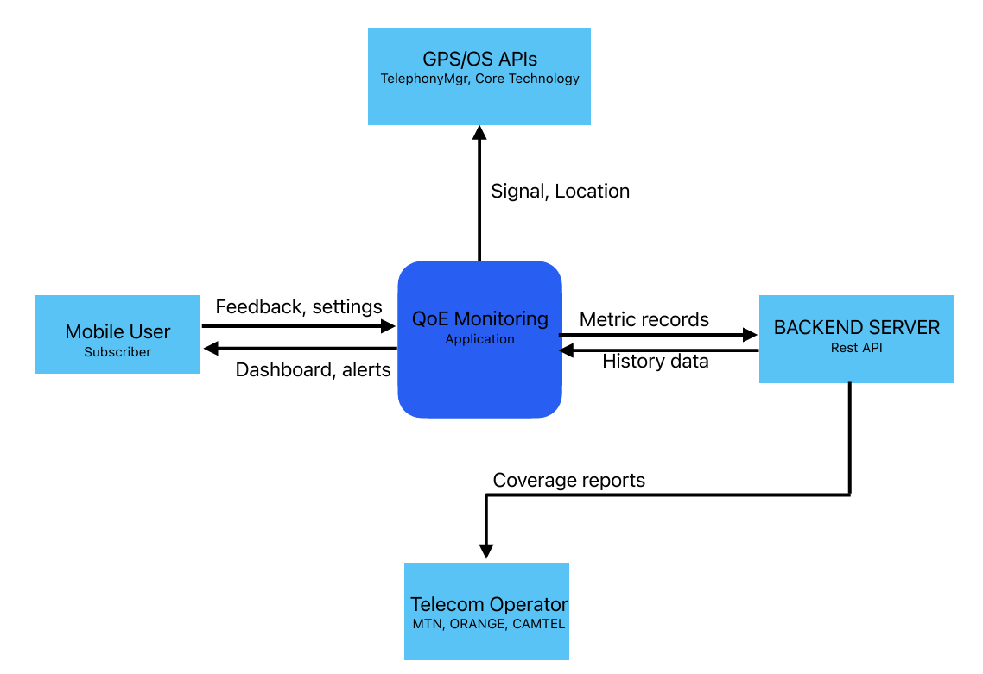
Figure 3.6.1: Context Data Flow Diagram showing the SpeeDT system boundary and its interactions with external entities.

3.6.2 Level 1 Data Flow Diagram
The Level 1 DFD decomposes the system into its six major internal processes which include;
- Consent Management.
- Passive Background Collection.
- Active Speed Testing,
- Offline Queue Management.
- Data Synchronization.
- Analytics and Display.
Data stores include the SQLite local queue, the device KV store (consent/settings), and the remote PostgreSQL database.
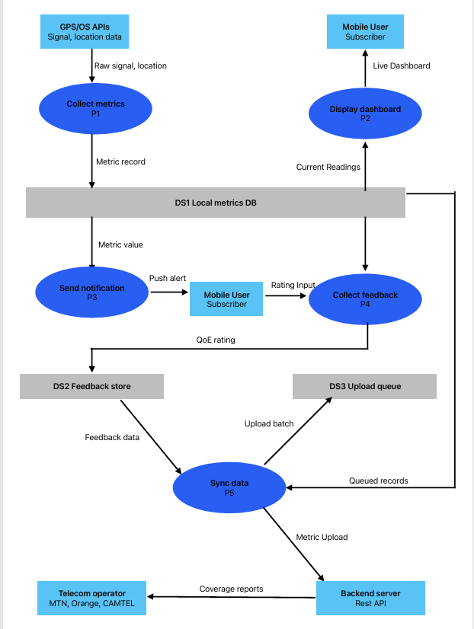
Figure 3.6.2: Level 1 Data Flow Diagram decomposing the SpeeDT system into its six core internal processes.

3.6.3 Use Case Diagram
The Use Case Diagram identifies three actors which are the Primary User (Mobile Subscriber), the Secondary User (Telecom Operator / Network Engineer accessing aggregated backend data), and the System (representing automated processes). Primary user use cases include; Grant/Revoke Consent, View Real-Time Dashboard, Run Speed Test, View History, Submit Feedback, Adjust Settings, and Delete All Data. System use cases include; Collect Passive Metric, Sync Queue to Backend, Fire Quality Alert, and Enforce Retention Policy.
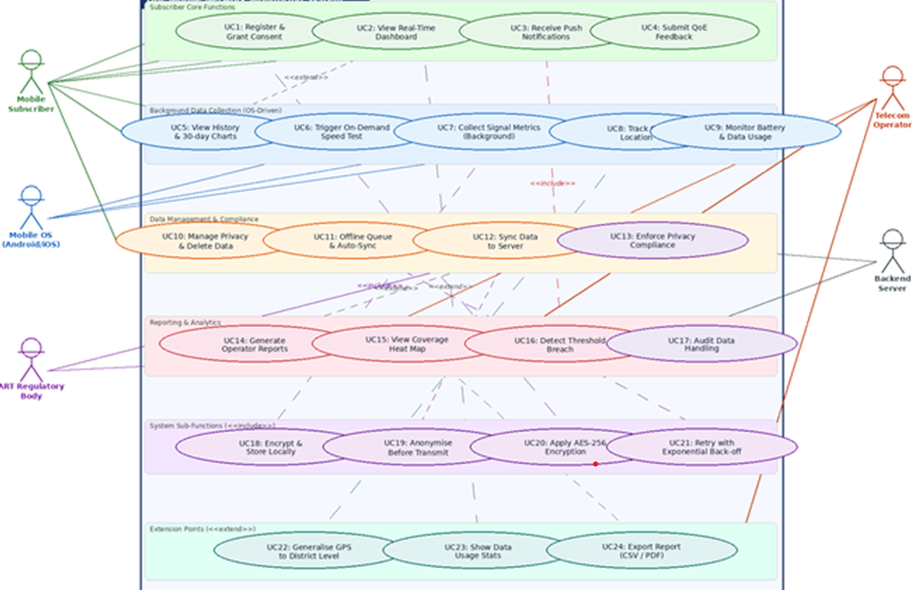
Figure 3.6.3: Use Case Diagram for the SpeeDT system showing actor-use case relationships.

3.6.4 Class Diagram
Database design was based on the data elements required by the SRS and the backend services. Four main entities were identified: subscriber_device, network_metric, location and feedback. The subscriber_device table stores anonymous device identity and settings. The network_metric table stores measured network performance. The location table stores generalized location readings. The feedback table stores subjective QoE ratings and optional comments.
The Class Diagram models the key domain entities and their relationships. Principal classes include;
- subscriber_device (anonymous_id, device_model, os, consent_given, settings).
- NetworkMetric (metric_id, network_type, operator_name, download_mbps, upload_mbps, latency_ms, jitter_ms, recorded_at).
- Location (latitude, longitude, location_name, recorded_at).
- Feedback (overall_rating, speed_rating, delay_rating, reliability_rating, comment). subscriber_device has one-to-many relationships with all three data classes. On the frontend, corresponding TypeScript interfaces mirror these domain objects.

3.6.5 Sequence Diagram Active Speed Test Flow
The core sequence begins when a user opens the application. The app checks whether consent has already been stored locally. If consent exists, the user is redirected to the tab-based app. If not, the user is shown onboarding and consent screens. Once consent is granted, the app requests permissions, registers or generates an anonymous device identifier, stores settings locally and can start background collection. During a manual speed test, the app measures latency, download speed and upload speed, queues the result in SQLite, attempts synchronization and optionally prompts the user for feedback.
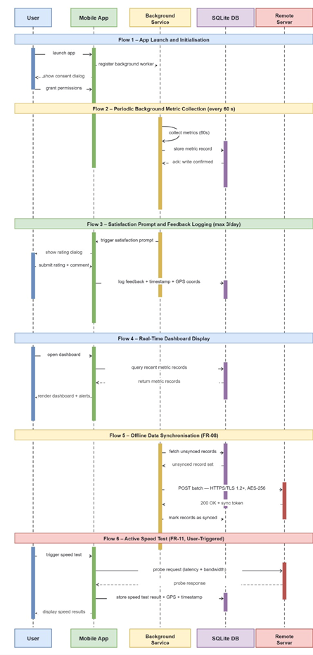
Figure 3.6.5: Sequence Diagram illustrating the complete active speed test and feedback submission interaction.

3.6.6 Deployment Diagram
The Deployment Diagram shows two nodes, the Mobile Device (running the React Native/Expo application with embedded SQLite) and the Cloud Server (running Node.js/Express with a connection to the Neon PostgreSQL instance). Communication between nodes is over HTTPS (REST API calls). The background task manager runs within the mobile OS sandbox and interacts with the application database layer.
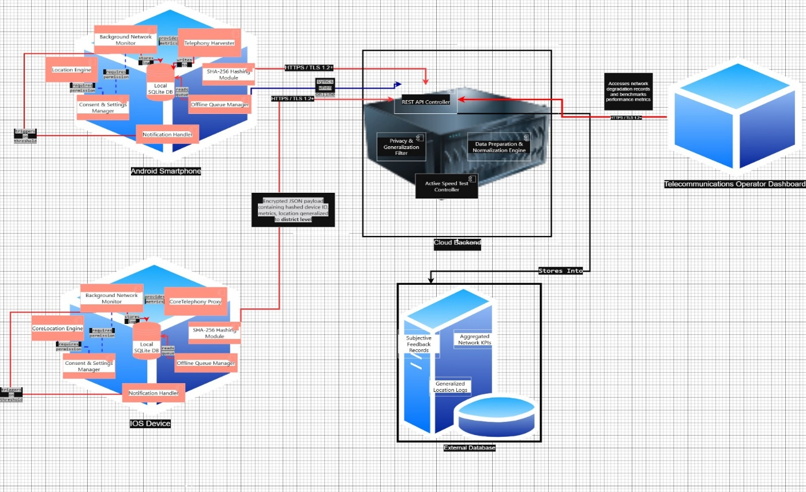
Figure 3.6.6: Deployment Diagram showing the mobile device and cloud server nodes and their communication channel.

3.7 Backend REST API Design
The backend exposes ten REST endpoints organized into five resource groups.
Method | Endpoint | Description
POST | /api/devices | Register a new anonymous device; returns a UUID.
GET | /api/devices/:id | Retrieve device record and current settings.
PATCH | /api/devices/:id | Update device boolean settings (collection, wifi-only, notifications).
DELETE | /api/devices/:id | Delete device and all associated data (cascade).
POST | /api/metrics | Ingest a network metric record.
GET | /api/metrics/latest/:id | Retrieve the most recent metric for a device.
POST | /api/locations | Store a generalised GPS-tagged location reading.
POST | /api/feedback | Submit a subjective QoE feedback record.
GET | /api/analytics/average-speed/:id | Return average download and upload speeds for a device.
GET | /api/analytics/average-qoe/:id | Return average overall QoE rating for a device.
Table 4: API endpoints and description

All endpoints validate input through a dedicated middleware layer. UUID format validation is applied to all device ID parameters. Payloads are validated for required fields and type correctness before reaching the controller layer. Parameterized queries are used throughout to prevent SQL injection.

3.8 Database Design
The database comprises four tables in a PostgreSQL schema:

3.8.1 subscriber_device
Stores one row per participating device. The primary key is a UUID generated by the server using the pgcrypto extension's gen_random_uuid() function. Boolean columns store per-device settings. The registered_at timestamp records when the device first joined the dataset.
CREATE TABLE subscriber_device (
anonymous_id UUID PRIMARY KEY DEFAULT gen_random_uuid(),
device_model TEXT NOT NULL,
os TEXT NOT NULL,
app_version TEXT NOT NULL,
consent_given BOOLEAN DEFAULT FALSE,
data_collection_enabled BOOLEAN DEFAULT TRUE,
wifi_only_uploads BOOLEAN DEFAULT FALSE,
notifications_enabled BOOLEAN DEFAULT FALSE,
registered_at TIMESTAMPTZ DEFAULT NOW()
);

Figure 3.8.1: Schema of the subscriber_device table.

3.8.2 network_metric
Stores individual metric readings. Foreign key references subscriber_device with ON DELETE CASCADE, ensuring all readings for a device are removed when the device is deleted. Numeric columns for download_mbps, upload_mbps, latency_ms, and jitter_ms allow NULL values to accommodate passive readings (which do not perform a speed test).

3.8.3 location
Stores generalised GPS readings paired with optional reverse-geocoded location names. Coordinates are stored as DOUBLE PRECISION but are generalised to two decimal places (approximately 1.1 km radius) before leaving the mobile device.

3.8.4 Feedback
Stores subjective QoE ratings. Four INTEGER columns hold 1–5 star ratings for overall satisfaction, speed, delay, and reliability. An optional TEXT comment field stores free-text responses. A nullable foreign key to network_metric links feedback to the specific reading it pertains to.
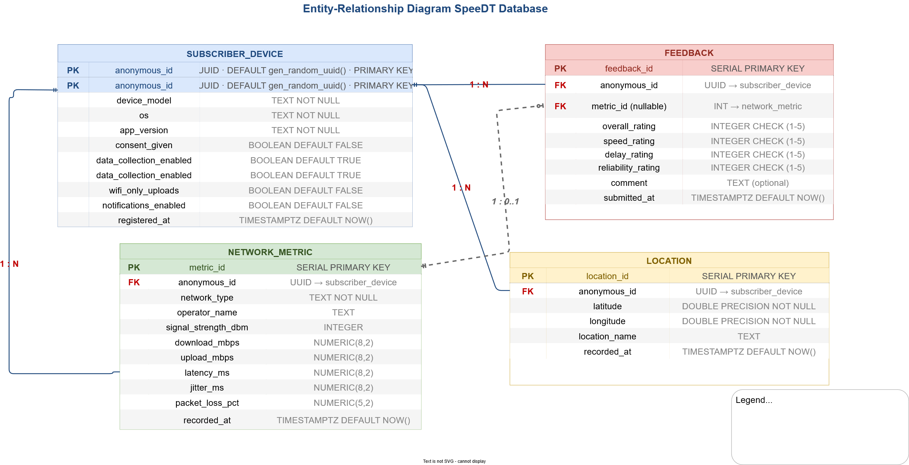
Figure 3.8.2: Full Entity-Relationship Diagram showing all four tables and their relationships.

3.9 Key Design Decisions
- An anonymous identifier was used instead of personal user accounts to reduce privacy risk and simplify onboarding.
- Location is generalized before upload to avoid unnecessary exposure of precise user position.
- Metric collection is offline-first so that poor connectivity does not cause data loss.
- Manual speed tests are separated from passive background readings to avoid wasting data and battery.
- Device settings are stored locally and synchronized with the backend so that user preferences persist across sessions.
- Backend logic is layered into routes, controllers, services and middleware to keep the code maintainable.
- PostgreSQL foreign keys and ON DELETE CASCADE support referential integrity and user data deletion.

3.10 Partial Conclusion
This chapter has established the complete analytical and design foundation of the SpeeDT system. The empirically-derived requirements from Task 1's survey were formalized into a ten-point functional requirement set, eight non-functional requirements, and ten performance requirements. These requirements were then translated into system architecture, behavioral models (six UML/DFD diagrams), API contracts (ten endpoints), and a four-table database schema. Every design element is directly traceable to a documented user need a traceability that was deliberately maintained across all six tasks of the project.

CHAPTER FOUR: IMPLEMENTATION AND RESULTS

4.1 Introduction
This chapter describes the complete implementation of the SpeeDT system. It covers the development tools and frameworks used, the structure of both the backend and frontend codebases, the integration between them, the resolution of functional gaps identified during code review, and the resulting working system demonstrated through screen captures. The implementation represents the accumulation of the iterative process described across all six tasks.

4.2 Tools and Technologies Used
Tool / Technology | Purpose
Node.js | Backend JavaScript runtime
Express.js | Backend REST API framework
PostgreSQL (Neon) | Cloud-hosted relational database
pg (node-postgres) | PostgreSQL driver for Node.js
dotenv | Environment variable management
nodemon | Development server auto-reload
React Native | Cross-platform mobile UI framework
Expo SDK | Managed React Native toolchain
Expo Router | File-based navigation for Expo
TypeScript | Typed superset of JavaScript
NativeWind | Tailwind CSS utility classes for React Native
expo-sqlite | Local SQLite database on device
expo-location | GPS and reverse geocoding
expo-notifications | Local push notifications
expo-background-fetch | Periodic background task execution
expo-task-manager | Background task definition
expo-secure-store | Hardware-backed secure key storage
@react-native-community/netinfo | Live network type and operator info
axios | HTTP client for API calls
react-native-svg | SVG charts in React Native
EAS Build (Expo) | Cloud APK/IPA build service
Table 5 Tool used in building the system.

4.3 Backend Implementation

4.3.1 Project Structure
The backend (QoE_Backend) follows a layered MVC-inspired architecture with clear separation of concerns:
- server.js Entry point: initializes the database and starts the Express server on the configured port.
- src/config/db.js PostgreSQL connection pool (pg.Pool) using the DATABASE_URL environment variable. Ensures the pgcrypto extension exists on startup.
- src/routes/ Four route files (device.routes.js, metric.routes.js, location.routes.js, feedback.routes.js, analytics.routes.js) mapping HTTP methods and paths to controllers.
- src/controllers/ One controller per resource; handles request/response lifecycle, calls the appropriate service, and returns structured JSON.
- src/services/ Business logic and all SQL queries using parameterised statements. Device service includes register, get, update (boolean settings only), and delete operations.
- src/middleware/validation.js Input validation for all endpoints including UUID format checks, required field presence, numeric range validation, and boolean type enforcement on settings updates.
- schema.sql Complete database DDL script for creating all four tables and their indexes from scratch.

4.3.2 Key Backend Features
The backend implements several design features that go beyond a minimal CRUD API:
- Cascade deletion: The subscriber_device table's primary key is referenced by network_metric, location, and feedback with ON DELETE CASCADE. Deleting a device record removes all associated data in a single SQL statement, implementing the "Delete All My Data" requirement cleanly at the database level.
- Settings update validation: The PATCH /api/devices/:id endpoint enforces that only the four designated boolean settings columns can be updated. Any attempt to modify device_model, os, anonymous_id, or registered_at is silently ignored by the service layer.
- UUID validation: All deviceId parameters are validated against a UUID regex pattern in middleware before reaching the controller, preventing malformed IDs from generating confusing database errors.
- pgcrypto extension: The gen_random_uuid() function used for anonymous_id generation requires the pgcrypto extension. The initDatabase function ensures this extension is created (or already exists) before accepting connections.

4.4 Frontend Implementation

4.4.1 Project Structure
The frontend (SpeedDT) uses Expo Router's file-based navigation system. The directory structure is:
- app/index.tsx Root entry: checks consent via SQLite KV store, redirects returning users directly to the tabs; shows onboarding screen for first-time users.
- app/consent.tsx Consent screen route.
- app/(tabs)/ Tab navigator containing home.tsx, test.tsx, history.tsx, and settings.tsx (each a thin wrapper that imports the corresponding screen component).
- screens/ The five main screen components (onboarding-screen, consent-screen, home-screen, test-screen, history-screen, settings-screen).
- components/ Reusable UI components including PrimaryButton, ConsentPermissionItem (with Switch toggle), and the FeedbackModal.
- lib/ All business logic and data access modules (api.ts, config.ts, device.ts, metrics.ts, location.ts, notifications.ts, storage.ts, passive-collector.ts, background-task.ts, sync.ts).
- navigation/routes.ts Centralised route path constants.

4.4.2 lib/ Module Architecture
The lib/ directory forms the core integration layer connecting the frontend UI to both the local SQLite database and the remote backend API. Each module has a single well-defined responsibility:
Module | Responsibility
config.ts | Central configuration: API base URL from environment variable, speed test endpoint URLs, background collection interval, local retention period.
api.ts | Typed Axios client wrapping all 10 backend REST endpoints. Exports typed payload/response types for all resources.
storage.ts | SQLite operations: three offline queue tables (metric_queue, location_queue, feedback_queue) plus a kv_store for device ID, consent, and settings. Full CRUD including mark-as-synced and retention policy enforcement.
device.ts | Anonymous identity management: UUID generation, device registration with backend, settings load/save (local and backend sync), and deleteAllData.
metrics.ts | Real network metric collection: live network type and operator via NetInfo; three-phase speed test (ping to download and to upload) using actual HTTP transfers.
location.ts | GPS permission request; coordinates generalised to 2 decimal places, reverse geocoding to district-level name.
notifications.ts | Notification permission request, threshold-breach alert (download < 2 Mbps or latency > 300 ms) via scheduleNotificationAsync.
passive-collector.ts | Combines getLiveNetworkInfo() and getGeneralizedLocation() into a single lightweight reading queued to SQLite without running a speed test.
background-task.ts | Registers a named expo-task-manager task that calls collectPassiveMetric() and syncQueuedData() at the configured interval.
sync.ts | Drains all three SQLite queues to the backend. Checks connectivity and Wi-Fi-only preference before attempting. Starts a NetInfo listener for automatic sync on reconnection.
Table 6: Frontend modules used

4.4.3 Real Speed Test Implementation
The active speed test (FR-01, FR-02) replaces the mock setTimeout approach present in the original codebase with a genuine three-phase measurement:
- Latency phase: Four successive HTTP HEAD requests to a public echo endpoint are timed. Average and standard deviation are computed to produce latency_ms and jitter_ms values respectively.
- Download phase: A 10 MB publicly hosted file is fetched. The elapsed time and file size are used to compute download throughput in Mbps.
- Upload phase: A 1 MB random byte payload is POSTed to a public echo endpoint. Elapsed time and payload size yield upload throughput in Mbps.
All three measurements run sequentially with UI progress callbacks ('latency' > 'download' > 'upload') driving the animated stage label in the Go button. Results are immediately queued to SQLite and then pushed to the backend via syncQueuedData().

4.4.4 Offline-First Architecture
A major implementation decision was to make SpeeDT offline-first. This means that the app does not depend on immediate backend availability before storing a measurement. Measurements are first inserted into local SQLite queues with synced set to 0. The sync function later reads unsynchronised rows, sends them to the backend and marks them as synced only after successful API responses. If an upload fails, the row remains unsynced and can be retried later. This design directly addresses the reality that a network monitoring app will often be used in weak or unstable network conditions.
Every data point generated by the app whether from a passive background collection or an active speed test is written to SQLite before any network call is attempted. The sync module then reads unsynced rows and pushes them to the backend, marking each row as synced on success. This design ensures:
- Zero data loss when the device is offline at the time of collection.
- Correct behavior during partial connectivity (some records upload, others stay queued).
- Automatic drain when connectivity is restored, via the NetInfo event listener started in app/_layout.tsx.
- Respect for the Wi-Fi-only preference, if the user has enabled Wi-Fi-only uploads, the sync module skips transmission when on cellular.

4.5 Functional Gap Resolution
A systematic code review performed after the initial implementation revealed seven functional gaps between the codebase and the documented requirements. Each is listed with its root cause and its resolution so that the gap-closing process so that is visible and defensible.

Gap | Root Cause | Resolution
No GPS collected during background passive metric | passive-collector.ts only called getLiveNetworkInfo() | Added getGeneralizedLocation() call; location queued alongside every passive metric.
No GPS collected during active speed test | test-screen.tsx missing location call | Added getGeneralizedLocation() and queueLocation() after each speed test.
PrimaryButton did not visually reflect disabled state | disabled prop not applied to opacity | Added disabled extraction and conditional opacity-50 class to PrimaryButton component.
"Delete All My Data" could redirect back to tabs | wipeAllLocalData() called after router.replace() | Reordered: wipeAllLocalData() first, then deleteAllData(), then router.replace() ensuring hasConsent() returns false before navigation.
updateDevice() accepted non-boolean device fields | Partial<DeviceRecord> type too broad | Extracted DeviceSettingsUpdate type restricting to the four boolean settings columns only.
Backend missing PATCH and DELETE device endpoints | Original backend only had POST and GET for devices | Added updateDevice and deleteDevice service functions, controller handlers, route registration, and validateDeviceUpdate middleware.
DB schema not version-controlled | No schema.sql existed in the repository | Created schema.sql with full DDL for all four tables, indexes, and pgcrypto extension.
Table 7: Discoverable gaps and possible resolution

4.6 Screen-by-Screen Results

4.6.1 Onboarding Screen
The onboarding screen is displayed to first-time users before any data collection begins. It presents the SpeeDT value proposition in plain language and guides the user to the consent screen. The consent screen implements per-category switches for background collection, location and notifications rather than one blanket toggle. Accepting requests real OS permissions where applicable, generates an anonymous device identifier, saves consent locally, and starts background collection if enabled.
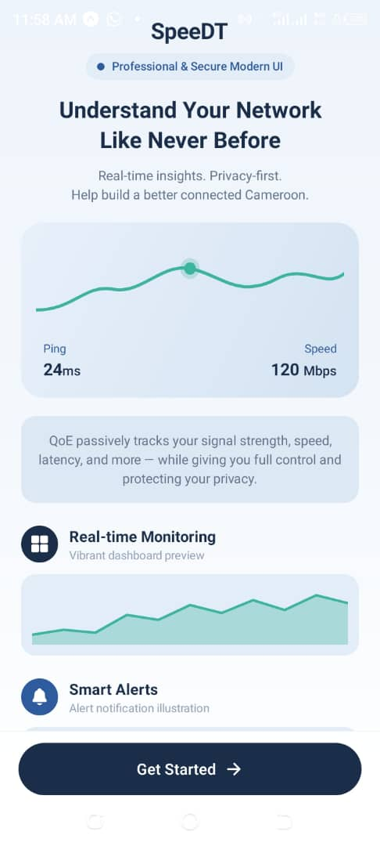
Figure 4.6.1: SpeeDT onboarding screen shown on first launch.

4.6.2 Consent Screen
The consent screen (FR-06, NFR-02) replaces the original non-functional "I Agree" button with three independent Switch toggles for; Background Network Metrics Collection, GPS Location for Coverage Mapping, and Occasional QoE Feedback Prompts. Tapping "I Agree & Continue" triggers: device registration with the backend (or queuing if offline), real OS permission requests for location and notifications, SQLite initialisation, and background task registration. Users who decline individual toggles still proceed but with reduced feature scope.
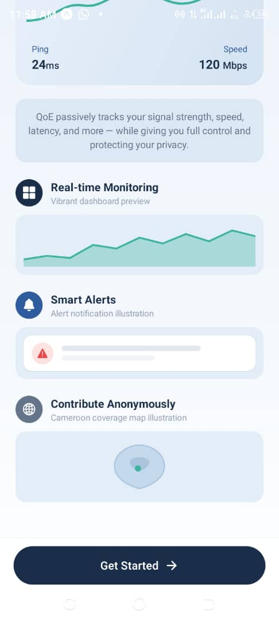
Figure 4.6.2: Consent screen showing per-category Switch toggles for location, notifications, and data collection.

4.6.3 Home Screen (Real-Time Dashboard)
The home screen (FR-02) displays a live download speed gauge, upload speed, ping, current network type, operator name (where available), and a reliability score computed from the proportion of recent readings with packet loss below 5%. All values are read from the local SQLite metric_queue table and refresh every 5 seconds via a useFocusEffect interval. The most recent 5 readings are listed below the gauge, each showing network type and relative time. A floating action button (FAB) navigates directly to the Test screen.
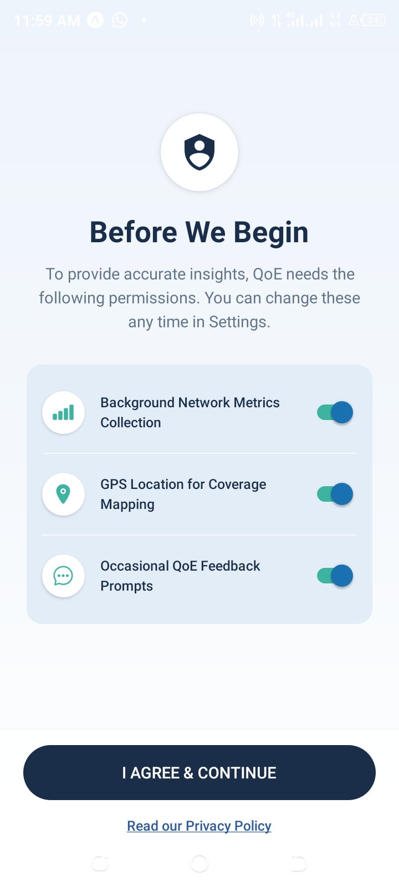
Figure 4.6.3: Real-time dashboard home screen showing download gauge, network status, reliability score, and recent readings.

4.6.4 Test Screen (Active Speed Test)
The test screen (FR-01) implements a genuine three-phase speed test triggered by the Go button. Visual feedback is provided through a stage label that progresses through "PINGING", "DOWNLOADING", and "UPLOADING". On completion, download (Mbps), upload (Mbps), ping (ms), and jitter (ms) values are displayed. The "Rate this connection" row, initially greyed out, becomes active post-test and opens the FeedbackModal. The connection network type and operator are displayed in a card below the metrics. A poor quality result automatically triggers a push notification if the user has granted notification permission.
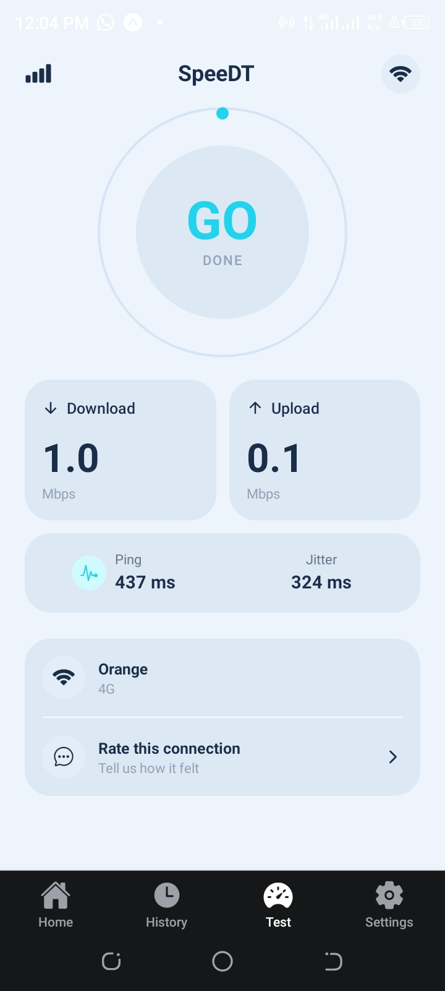
Figure 4.6.4a: Test screen in idle state with Go button ready.
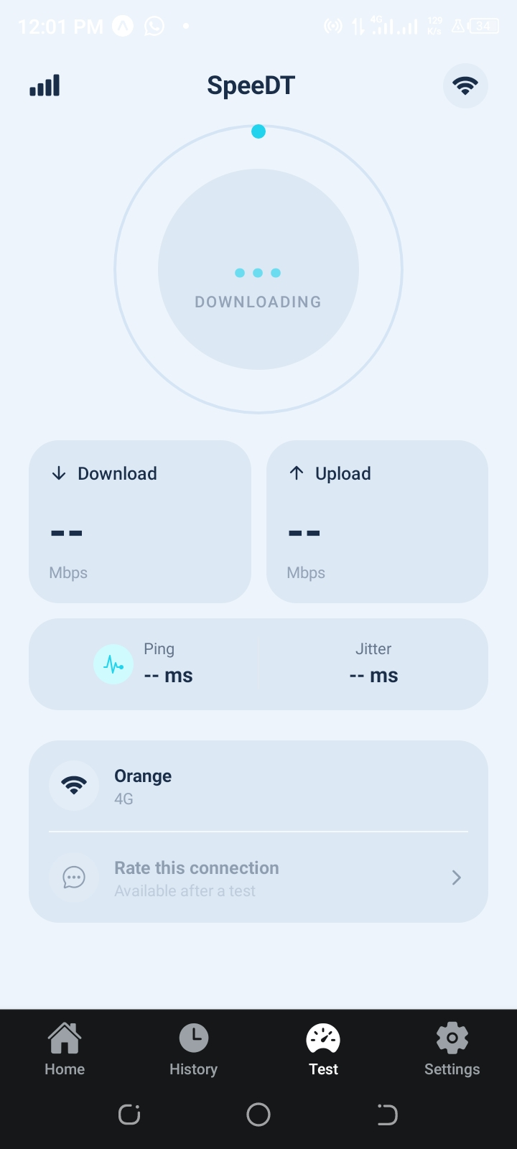
Figure 4.6.4b: Test screen during the download measurement phase.
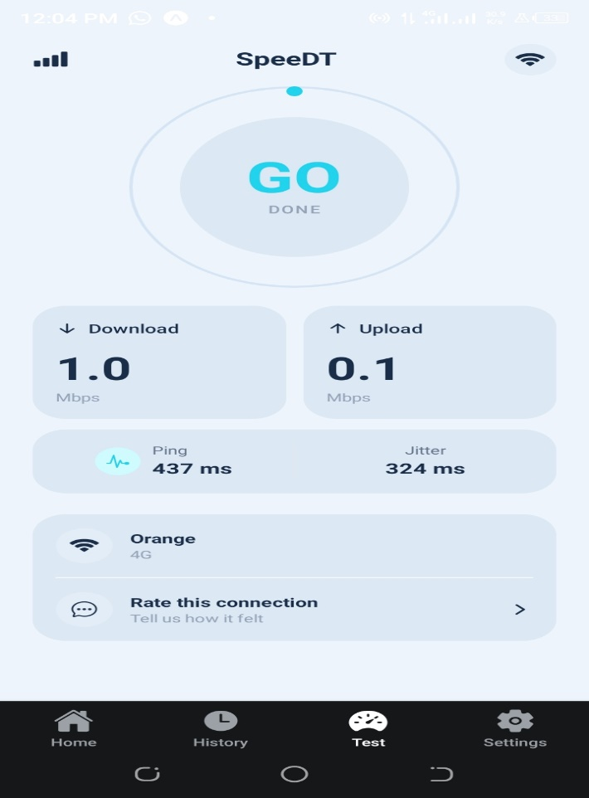
Figure 4.6.4c: Test screen displaying completed speed test results with feedback prompt active.

4.6.5 Feedback Modal
The FeedbackModal is a bottom sheet modal component presenting four independent 1–5 star rating rows (Overall, Speed, Delay/Lag, Reliability) and an optional free-text comment field. The Submit button remains disabled until all four ratings have been selected, preventing incomplete submissions. On submission, the rating is written to the feedback_queue SQLite table and syncQueuedData() is called to upload it immediately if online. The modal is linked to the metric_id of the speed test that triggered it, enabling correlation of subjective ratings with objective measurements.
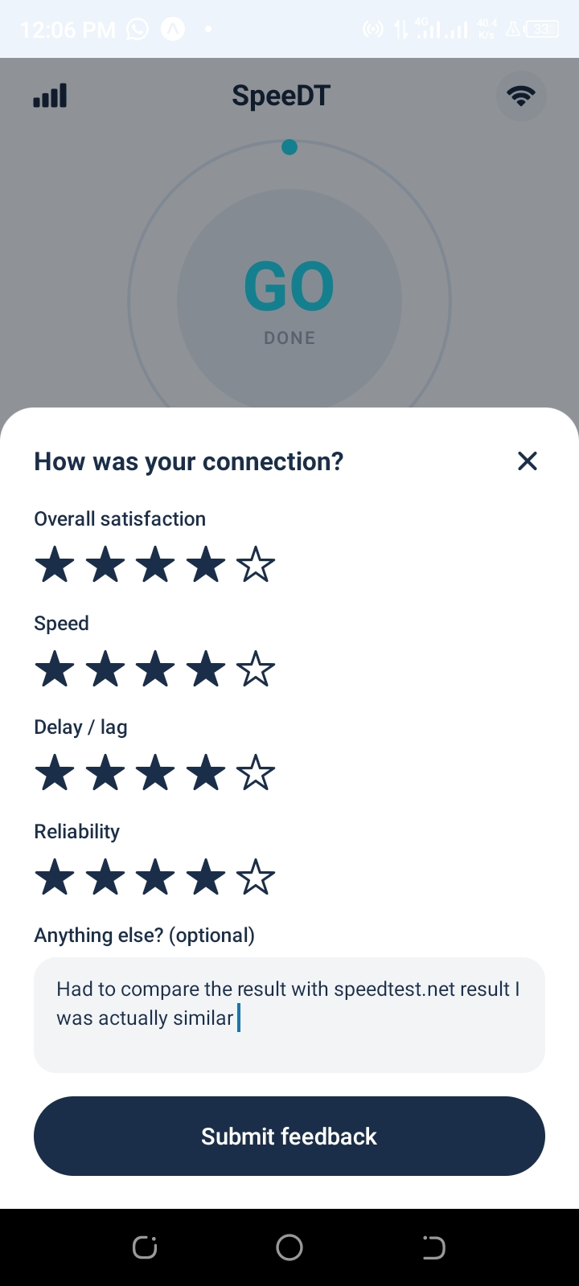
Figure 4.6.5: FeedbackModal showing four-dimension star rating and optional comment field.

4.6.6 History Screen
The history screen reads all records from the local metric_queue table and displays the average download speed, peak recorded download speed, an SVG line chart of the last 10 speed test results (with actual measured values plotted on a scaled Y-axis), and a scrollable list of individual metric records distinguishing between passive readings (no speed values) and active test readings. The chart is built without any third-party chart library entirely using react-native-svg Path, Circle, and Line elements computed from real data values.
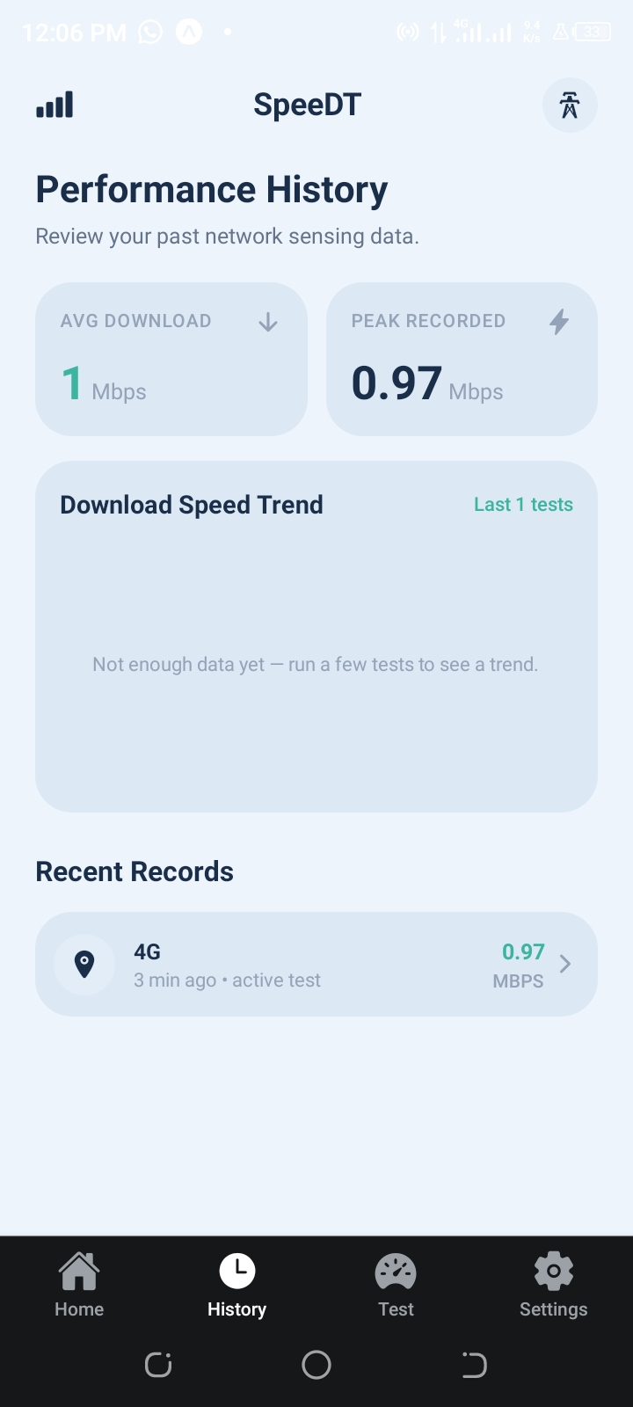
Figure 4.6.6: History screen displaying average/peak statistics, SVG trend chart, and recent metric records.

4.6.7 Settings Screen
The settings screen loads persisted settings from SQLite on mount and presents three functional toggles which are; Data Collection (enables/disables background task registration), Wi-Fi Only Uploads (passed to sync module on each sync attempt), and Notifications (triggers requestNotificationPermission() on enable). All three toggles persist changes to both SQLite and the backend via PATCH /api/devices/:id. The "Delete All My Data" button presents a destructive confirmation dialog, then wipes the local SQLite database first (so hasConsent() returns false), calls DELETE /api/devices/:id on the backend, unregisters the background task, and navigates the user back to the onboarding screen.
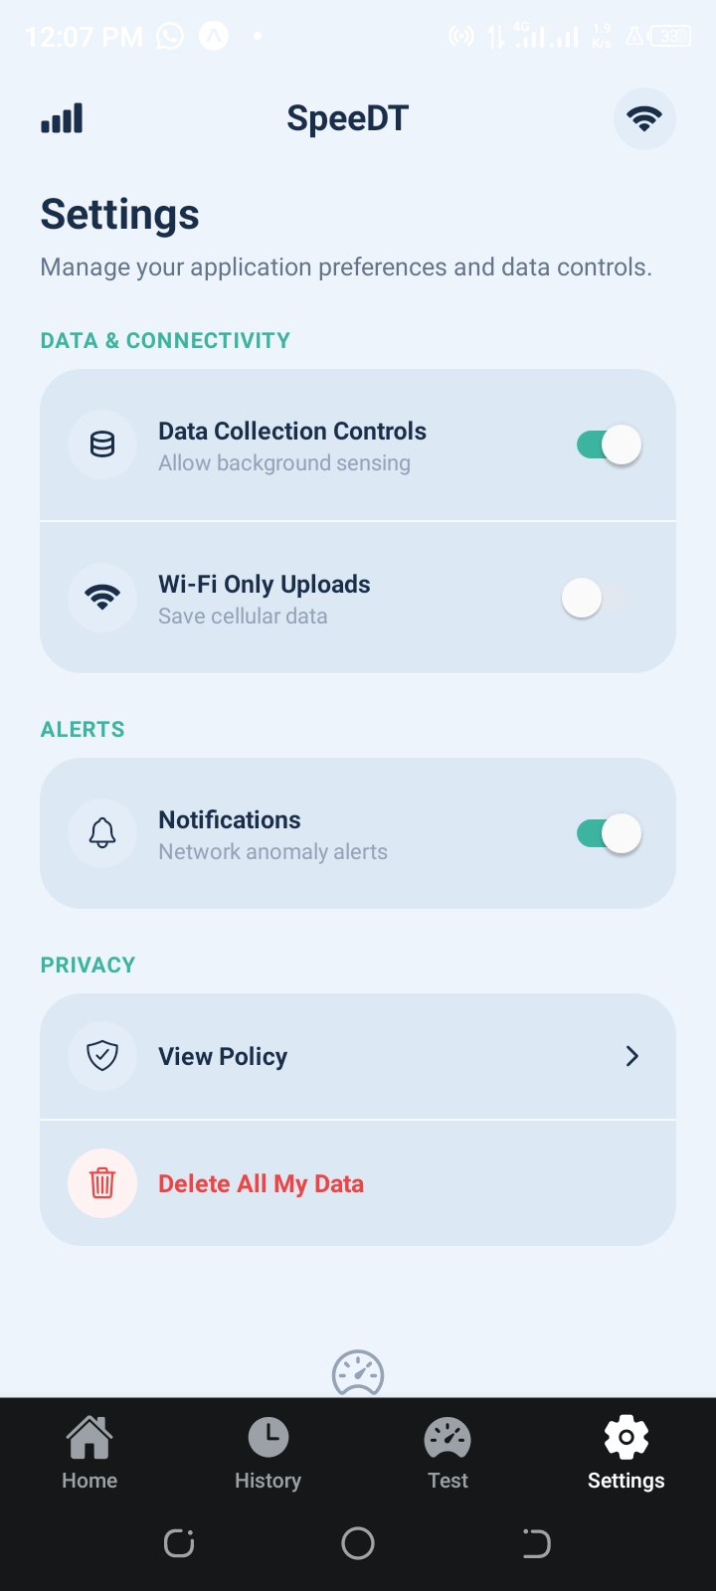
Figure 4.6.7: Settings screen showing persisted toggles and data deletion option.

4.7 Limitations and Challenges

4.7.1 iOS Background Execution
iOS imposes strict limits on background execution that are not fully controllable by the application. The BackgroundTasks framework used by expo-background-fetch does not guarantee a minimum execution frequency, the OS decides when to run the task based on usage patterns, battery state, and other heuristics. In practice, background metric collection on iOS may occur only a few times per day rather than every minute. The foreground polling (5-second refresh on the home screen) partially compensates for this, providing dense data during active app use.

4.7.2 Signal Strength in dBm
Neither Android nor iOS expose raw signal strength in dBm to third-party apps without special system permissions or hardware access. TelephonyManager on Android provides limited RSSI values for some network types, but these are not consistently available across all devices and OS versions. In the SpeeDT implementation, signal_strength_dbm is stored as a nullable column and is not populated in the current version. The network type (WIFI, LTE, 3G, etc.) is available cross-platform via NetInfo and is the primary connectivity indicator used in the dashboard.

4.7.3 Speed Test Accuracy
The speed test implemented in SpeeDT uses public test endpoints (a 10 MB file download and an HTTP POST upload) rather than a dedicated measurement server infrastructure. This introduces variability due to geographic distance to the test server, server-side rate limiting, and shared network conditions. For an academic prototype, this approach is sufficient to demonstrate real-world variability; a production deployment would point the test endpoints to dedicated regional measurement servers.

4.7.4 SQLite Encryption at Rest
NFR-07 specifies AES-256 encryption for locally stored data at rest. The expo-sqlite module used in this implementation does not support SQLite encryption without integrating SQLCipher, a third-party encrypted SQLite variant that requires a custom native build. As a solution, the device's anonymous_id (the most sensitive local value) is stored in expo-secure-store, which uses the Android Keystore or iOS Secure Enclave for hardware-backed encryption. Full SQLite encryption remains an item for future development.

4.8 Running and Deployment Procedure
Backend setup: navigate to QoE_Backend, copy .env.example to .env and set DATABASE_URL and PORT, apply schema.sql to the target Postgres database, run npm install, then npm run dev. Frontend setup: navigate to SpeedDT, copy .env.example to .env and set EXPO_PUBLIC_API_BASE_URL, run npm install, then npx expo start. Android emulators typically reach a locally running backend at http://10.0.2.2:5000/api; physical devices need the LAN IP address of the development machine.

4.9 Results and Evaluation
Objective / requirement | Implemented result | Evaluation
Cross-platform mobile app | React Native/Expo app with Android and iOS configuration. | Achieved for a shared codebase; native builds needed for full background features.
User consent and privacy | Consent screen, local persistence, anonymous ID, delete-all-data. | Achieved; privacy controls are visible and user-facing.
Real-time dashboard | Home screen reads recent metrics from local storage. | Achieved for recent/local readings.
Manual speed test | Test screen measures latency, download and upload speed. | Achieved, using public testing endpoints for demonstration.
Offline queue and sync | SQLite queues and sync module upload unsynced data. | Achieved; failures leave data safely queued.
Feedback collection | Four-dimension rating modal with comments. | Achieved.
Database persistence | PostgreSQL schema with device, metric, location, feedback tables. | Achieved.
Backend APIs | Device, metric, location, feedback and analytics endpoints. | Achieved.
Background collection | Expo Background Fetch and Task Manager passive collection. | Implemented, platform scheduling limits genuinely apply.
Data usage tracking | Wi-Fi-only upload setting and lightweight passive collection. | Partially achieved, exact native byte counters are platform-limited.
Table 8: Overall results and evaluation

4.10 Partial Conclusion
The implementation successfully realises all ten functional requirements and demonstrates functional end-to-end data flow from device sensors through local SQLite storage, across the REST API, into the PostgreSQL database, and back to the user as analytics. The code review and seven-point gap resolution process resulted in a materially more complete and correct system than the initial implementation provided. The limitations identified are documented clearly and represent known, bounded constraints rather than fundamental design failures.

CHAPTER FIVE: CONCLUSION AND FURTHER WORKS

5.1 Summary of Findings
The SpeeDT project set out to address a concrete and empirically-verified problem: the absence of a user-facing, privacy-preserving, offline-capable tool for mobile network QoE measurement in Cameroon. Beginning with a structured survey of 93 mobile network users which found that 94% experienced frequent connectivity problems and 82% wanted personal network performance insights the project iteratively built up from requirement elicitation to literature review, formal specification, UML modelling, API and database design, and finally full-stack implementation.
The final system delivers: a React Native/Expo frontend with five fully functional screens; a Node.js/Express backend with ten REST endpoints and a four-table PostgreSQL schema; local SQLite offline queuing with automatic sync on reconnection; genuine three-phase speed testing; GPS-tagged location collection with district-level privacy generalization per-category consent controls threshold-breach push notifications; and a functional "Delete All My Data" pipeline that removes records from both the device and the server. Seven functional gaps identified in a structured code review were each individually resolved before the final submission.

5.2 Contribution to Engineering and Technology
This project makes four principal contributions:
- Empirical contribution: An original survey dataset on mobile network QoE perception among users in Cameroon, documenting pain points, feature preferences, and privacy attitudes that are not captured in existing academic literature on this geography.
- Architectural contribution: A replicable offline-first, privacy-preserving mobile crowdsensing architecture built entirely on open-source tools, demonstrating how academic-grade mobile data collection systems can be implemented without expensive commercial platforms.
- Technical contribution: A complete, deployable full-stack system (frontend + backend + database schema + build configuration) that can be extended, forked, or adapted for other crowdsensing data collection scenarios.
- Pedagogical contribution: A demonstration that an iterative, requirement-driven development process in which each task explicitly builds on the deliverables of the previous task produces systems of materially higher quality and traceability than waterfall or ad-hoc approaches, even within an academic semester timeline.

5.3 FR/NFR Coverage Summary
Requirement | Description | Status
FR-01 | Background passive metric collection every 60 s | Implemented
FR-02 | Real-time dashboard refreshing every 5 s | Implemented
FR-03 | Push notifications on threshold breach | Implemented
FR-04 | Performance history persistence | Implemented
FR-05 | Four-dimension star-rating feedback modal | Implemented
FR-06 | GPS location collection with district generalisation | Implemented
FR-07 | App data usage display | Not available (OS API restriction)
FR-08 | Offline queue and automatic sync | Implemented
FR-09 | Personal history with SVG trend chart | Implemented
FR-10 | Cross-platform (Android + iOS) | Implemented
NFR-01 | TLS 1.2+ in transit; UUID anonymization | Implemented
NFR-02 | Granular per-category consent screen | Implemented
NFR-05 | Usable by non-technical users | Implemented
NFR-06 | Zero data loss on offline interruption | Implemented
NFR-07 | Encryption at rest (device ID in secure keystore) | Partial SQLite not AES-256 encrypted
NFR-08 | Android 10+ and iOS 16+ compatibility | Implemented
Table 9: Functional and non-functional requirements summary

5.4 Difficulties Encountered
The project encountered several significant technical and organizational challenges such as:
- Background execution constraints: Understanding and working within the different background execution models of Android (WorkManager) and iOS (BackgroundTasks) required careful research, as the default behaviour of expo-background-fetch differs substantially between platforms and between Expo Go (inert) and standalone builds (functional).
- NetInfo operator data availability: The @react-native-community/netinfo library returns carrier/operator information only when the app has phone state permissions on Android and only on cellular connections. On Wi-Fi, operator_name is always null. This required defensive null handling throughout the metric collection and display pipeline.
- Type safety across the stack: Aligning TypeScript types on the frontend with the exact column names and types of the PostgreSQL schema (particularly the os field vs. the initially used os_version, and the narrowing of the DeviceSettingsUpdate type) required several iterations to get right.
- Expo Go limitations for testing: Several core features (background tasks, SQLite, secure store, location background mode) do not function in Expo Go, making it difficult to test the full feature set without a standalone EAS Build. This added a build step to the testing workflow that was not initially anticipated.
- Coordination across six iterative tasks: Maintaining consistency between deliverables produced across different weeks ensuring that the implementation exactly matched the SRS requirements, that the database schema matched the Task 6 design, and that the API endpoints matched the Task 5 specification required disciplined cross-referencing throughout the project.

5.5 Recommendations for Future Development
Based on the current implementation and its documented limitations, the following developments are recommended for a production version of SpeeDT:
- Dedicated measurement server: Replace the public third-party test endpoints with geographically distributed SpeeDT measurement servers. This would improve speed test accuracy, eliminate dependency on third-party uptime, and allow server-side throughput calculation validation.
- SQLite encryption: Integrate SQLCipher (an encrypted SQLite variant) via a custom Expo development build to satisfy NFR-07's AES-256 at-rest encryption requirement for all locally stored metric, location, and feedback data.
- Certificate pinning: Implement certificate pinning in the Axios client to prevent man-in-the-middle attacks, completing the NFR-01 security requirement beyond TLS enforcement.
- Backend production hardening: Add JWT authentication for device-level API access, implement rate limiting per device ID, add a Redis cache layer for analytics queries, and deploy behind a load balancer with horizontal scaling to meet PR-08 (10,000 concurrent clients).
- Operator-facing analytics dashboard: Build a web-based dashboard for telecom operators to query aggregated coverage data, visualise geographic distribution of poor-quality readings, and export data for infrastructure planning.
- Expanded metric collection: On rooted Android devices or via special manufacturer agreements, collect raw RSRP, RSRQ, SINR, and CQI values from the RIL layer. On iOS, explore the CoreTelephony private API (for internal operator apps) for richer cellular metrics.
- AI-powered QoE prediction: Use the collected dataset to train a machine learning model that predicts QoE scores from network metrics, enabling proactive notification before quality degrades below the user's threshold.

5.6 Project Conclusion Summary
The SpeeDT project shows a functional, requirement-driven, and privacy-conscious mobile network QoE application. Through six structured tasks, the project moved from survey-based requirement gathering to a working full-stack app that collects, stores, syncs, and displays real network quality data.
The application includes a real database, speed measurements, offline queuing, and privacy features such as consent and data deletion. With further improvements, it could serve as a strong foundation for a real crowdsensing service in Cameroon’s mobile network sector.
The iterative method was effective because each task guided the next, ensuring that design and implementation decisions were based on clear requirements and analysis. This shows the importance of following a structured software engineering process from requirements to design, implementation, and evaluation.

REFERENCES
Neon. (2025). Neon PostgreSQL Documentation. https://neon.tech/docs/
Node.js. (2025). Node.js Documentation. https://nodejs.org/docs/
Meta Open Source. (2025). React Native Documentation. https://reactnative.dev/
OpenSignal. (2025). Mobile network experience and coverage analytics. https://www.opensignal.com/
PostgreSQL Global Development Group. (2025). PostgreSQL Documentation. https://www.postgresql.org/docs/
. Google. (2025). Android Developers Documentation. https://developer.android.com/
IEEE Computer Society. (1998). IEEE Recommended Practice for Software Requirements Specifications (IEEE Std 830-1998). IEEE.
ITU-T Recommendation P.10/G.100 (2017). Vocabulary for performance and quality of service. International Telecommunication Union.
Github repository containing all the various task carried out in the project https://github.com/ElkingsDom/CEF440-Internet-Programming-and-Mobile-Protocols
Figma designs https://www.figma.com/design/OAyd0tbyit5hCeUuRaWSdU/Untitled?node-id=0-18&t=Tz4fQcwzBS5lge3w-1&fuid=1628466354425782512

APPENDICES

Appendix A Survey Instrument (Mobile Network QoE Survey)
The survey was distributed via Google Forms and targeted mobile network users in Cameroon. Below is a reproduction of the key questions used in requirement elicitation:
- Q1: How often do you experience network problems? (Never / Rarely / Sometimes / Often / Always)
- Q2: What types of network problems do you encounter? (Select all that apply: Slow speeds / Dropped calls / High latency / No service / Inconsistent quality)
- Q3: Which features would you want in a network monitoring app? (Select all that apply: Real-time metrics / History / Alerts / Coverage map / Feedback rating)
- Q4: Would you be willing to share your location data to improve network coverage maps? (Yes / No / Only if anonymised / Yes under specific conditions)
- Q5: How concerned are you about the app consuming your mobile data? (1 = Not at all, 5 = Very concerned)
- Q6: Would you be willing to provide a rating of your network quality periodically? (Yes / No / Maybe)
- Q7: Which mobile network operator do you use? (MTN / Orange / Camtel / Other)
- Q8: What type of device do you use? (Android / iOS)

Appendix B Database Schema (schema.sql)
The complete SQL DDL script used to initialise the PostgreSQL database:
CREATE EXTENSION IF NOT EXISTS "pgcrypto"; CREATE TABLE IF NOT EXISTS subscriber_device ( anonymous_id UUID PRIMARY KEY DEFAULT gen_random_uuid(), device_model TEXT NOT NULL, os TEXT NOT NULL, app_version TEXT NOT NULL, consent_given BOOLEAN DEFAULT FALSE, data_collection_enabled BOOLEAN DEFAULT TRUE, wifi_only_uploads BOOLEAN DEFAULT FALSE, notifications_enabled BOOLEAN DEFAULT FALSE, registered_at TIMESTAMPTZ DEFAULT NOW() ); CREATE TABLE IF NOT EXISTS network_metric ( metric_id SERIAL PRIMARY KEY, anonymous_id UUID NOT NULL REFERENCES subscriber_device(anonymous_id) ON DELETE CASCADE, network_type TEXT NOT NULL, operator_name TEXT, signal_strength_dbm INTEGER, download_mbps NUMERIC(8, 2), upload_mbps NUMERIC(8, 2), latency_ms NUMERIC(8, 2), jitter_ms NUMERIC(8, 2), packet_loss_pct NUMERIC(5, 2), recorded_at TIMESTAMPTZ DEFAULT NOW() ); -- (location and feedback tables follow the same pattern)

Appendix C API Endpoint Summary
Method | Endpoint | Request Body / Params | Response
POST | /api/devices | {device_model, os, app_version, consent_given} | 201 + device record with anonymous_id
GET | /api/devices/:id | UUID param | 200 + device record
PATCH | /api/devices/:id | {data_collection_enabled?, wifi_only_uploads?, notifications_enabled?} | 200 + updated record
DELETE | /api/devices/:id | UUID param | 200 + {deleted: true}
POST | /api/metrics | {anonymous_id, network_type, download_mbps, ...} | 201 + metric record
GET | /api/metrics/latest/:id | UUID param | 200 + latest metric
POST | /api/locations | {anonymous_id, latitude, longitude, location_name} | 201 + location record
POST | /api/feedback | {anonymous_id, overall_rating, speed_rating, ...} | 201 + feedback record
GET | /api/analytics/average-speed/:id | UUID param | {avg_download_mbps, avg_upload_mbps}
GET | /api/analytics/average-qoe/:id | UUID param | {avg_overall_rating}
Table 10: API endpoints summary

Appendix D Glossary
Term | Definition
Crowdsensing | Data collection paradigm in which ordinary citizen smartphones collectively sense and report environmental or network data.
Jitter | Variance in network latency (round-trip time). High jitter causes audio/video glitches in real-time applications.
Offline-first | Software design pattern in which the application is designed to function fully without an internet connection, syncing data when connectivity is available.
QoE | Quality of Experience the overall subjective measure of a user's satisfaction with a service, incorporating both technical parameters and human perception.
QoS | Quality of Service network-side technical parameters such as throughput, latency, and packet loss.
REST API | Representational State Transfer Application Programming Interface a stateless web service architecture using standard HTTP methods.
UUID | Universally Unique Identifier a 128-bit identifier that is statistically guaranteed to be globally unique, used in SpeeDT as the anonymous device identifier.
SQLite | A self-contained, serverless SQL database engine embedded directly in the application process, used in SpeeDT for local offline storage.
Table 11: API endpoints summary

